Introduction

Jesse Hilton Stuart, (August 8, 1906- February 17, 1984) a famous American writer, was born and raised in Greenup County, Kentucky. He was the second of seven children. His father was a coal miner and a tenant farmer, and even though he himself was uneducated he always wanted his children to have the best education that they could. Jesse was very fond of writing all throughout school. After graduating high school he attended Lincoln Memorial University, where he wrote over five hundred poems. After graduation Jesse headed back to his hometown. By the age of nineteen he decided to become a school teacher. He believed that good teaching and education were important having a lasting effect on students. Jesse was very much in favor of the "new education" which encouraged the learning of new subjects, learning by "doing" (=experiencing) and a type of discipline that was meant to teach students rather than to make them feel ashamed. Jesse also believed that teachers should inspire students and build character.
Growing up in the country, Jesse found all of his inspirations for his writings. He always did his best work when he was just writing at home. Jesse always said that all his stories were based on true stories that happened to him or people he knew.

Contents

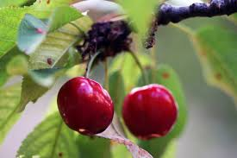

The Split Cherry Tree is one of Jesse Stuart’s narrative texts about the life of isolated farmers. In this story, Dave is the first in his family to go to high school. For his biology class, Dave goes on a field trip to search for creatures to dissect and study. Dave and five of his friends spot a lizard on a cherry tree, climb the tree to get it, and break the tree. The owner of the tree charges the boys six dollars – one dollar each - but Dave could not pay the dollar. Dave’s teacher, Mr. Herbert, pays for Dave but then asks Dave to pay him back by doing some chores after school. Dave cannot afford to stay after school because he has to help his strict dad, Luster, on the farm and asked to be whipped instead but Mr. Herbert does not agree.

When Dave finally arrives home, his dad is mad because he had to do the farm chores alone. Dave explains what happened at school but Luster is not completely convinced about Dave’s biology excuse and decides to go to the school in the morning with his gun; “I aim to see about bug larnin' and this runnin' all over God's creation huntin' snakes, lizards, and frogs.” Mr. Herbert is frightened of Luster’s overall presence with a gun and Luster is ignorant of all school related subjects. Throughout the day, Luster “shadows” Mr. Herbert and learns about school in the present time. When the day is over, Mr. Herbert tells Dave to forget the debt but Luster tells Dave to pay it back; they both stay to payback the debt. In the end, Luster apologizes to his son for his ignorance about school and tells him to always pay his debts.

Analysis and Interpretation

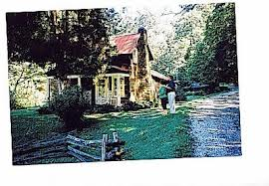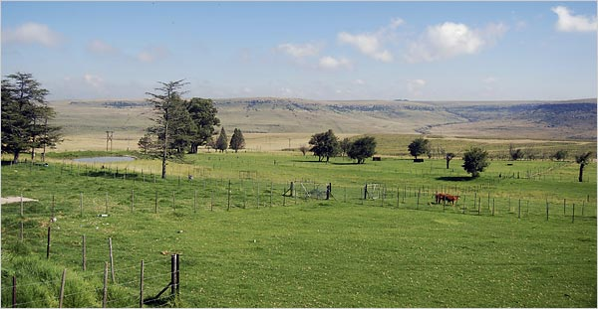

The story The Split Cherry Tree was written about rural America in the first half of the 20th century, when ideas in education that had begun in American cities were beginning to influence schools in the rural areas as well.

Pa, Dave's father, is a hard, uneducated man with firm beliefs. At the beginning, he is stubborn and narrow-minded about his beliefs on traditional education. He is very strict with Dave and threatens to whip him for being late. He believes that his children must listen to him – "If you spare the rod, you spoil the child". He is big and rough, and wears overalls and boots to go to the school. At the end, however, he realizes that the world has changed and that he is old-fashioned. When Professor Herbert introduces him to biology, he accepts the fact that there is a need of a new education. We see a kinder side of him. He is honest and kind to animals that are weaker than him. He understands the justice of the punishment and helps Dave to carry it out. He shows that he can change and is open to new ideas and methods. He wants his son to have a better education than he had.

Stuart’s story shares with the readers how farmers have worked all their lives and are ignorant of school related material. In this story, both Luster and Dave are outsiders in the “school-world.” Luster is a farmer whose only experience has been revolved around hard farm work and is unaware of school’s teaching material, as it is seen when Dave justifies his tardiness to help his dad with the farm. When he tries to complain to Mr. Herbert about his biology teaching, Luster makes a fool out of himself because he is ignorant. Dave, however, is an outsider because he is the first in his family to go to high school but also because he has to work on the farm immediately after school.

This story is particularly interesting, however, because Luster accepts his position as an outsider and “backs off” of Dave. This happens when Luster is willing to listen to Mr. Herbert, who represents modern education (he takes his students on a field trip so they can have a hands-on learning experience and he tries to be fair when he punishes the boys), and teaches Luster patiently about germs and biology. He becomes aware of the changes that schools have undergone since he went to school years ago. He realizes that he has been isolated from society by maintaining a farm out in the country.

Stuart’s use of an outsider character is obvious as soon as Luster is introduced into the story. But the situation improves because the outsider accepts his status and lets things be and in the process he becomes a better person. He also realizes that his son and him are part of two different generations in which things are done and taught differently. This acceptance is more or less identifying the "split" in outside-insider status and thus, represents the split in the cherry tree; the father and son may have been part of the same family but also belong to a different period of time.

