Sunday October first, 2017 Editor-Idan Viskos

**Idan's News**

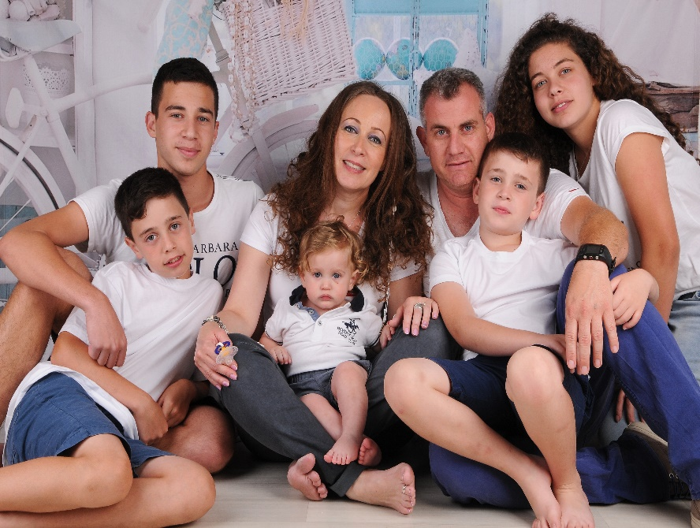

**A Happy Event**

It was a happy and pleasant event to have a new baby brother who had joined to our big family in the last one and half year.

**The Meaning Of My Name:** Idan,is an era/a period.

**My Hobbies**

I practice 3 time a week in Acrobatic Center,since I was 7 years old.Moreover every Friday I play soccer with my friens.

I also like to play on the computer at home.

My Family

I have a really big family!

My father is 45 years old.

My mother is 44 years old.

I have one older sister-Rotem'she is in 12 grade at Ort Bialik School.

And three little brothers-Itay is 12 years old,Gilad is 8 years old and Ohad is only one year and five month.

**My Favorites**

My favorite food-is fried Schnizel with Couscous and cooked vegetabels. But I will never say no for some slices of Pizza! For desert,I would like to have a tricolad cake.

My favorite sport type-is soccer because is very fun to watch and play with friends.Additionally it is uniting people from all over the world together no matter where they are from.