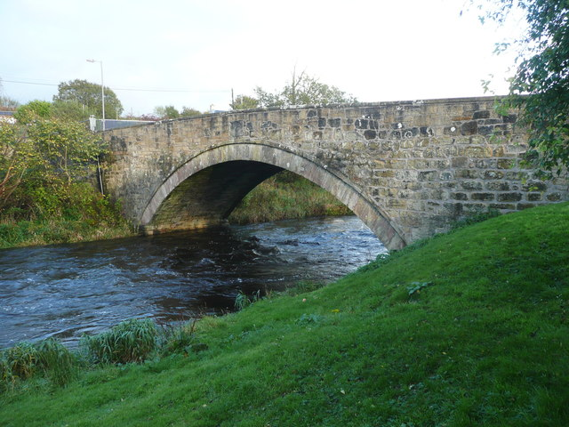
The Bridge – The connection between them
How to Answer the Bridging Question
Text - story /poem/play

Context - quote / information

What is the Bridging Text and Context question?
The Bridging Text and Context question requires students to connect a quote or new information to a story or poem that they have studied. The answer to the Bridging Text and Context question should be a paragraph of 80-100 words for Module F and should relate only to the parts of the story or poem that are relevant to the new information.

The questions types
What is the quote about? Who is the speaker and/or who is he/she speaking to?
Explain what the quote says in your own words.
How does the quote connect to the text?
Give at least one example of the connection to the text.
How does the quote add to your understanding of the text?

The “formula”
The following “formula” is suggested for a complete answer:
- Explain the quote / information in your own words
- Give at least TWO examples from the text that support the quote / information given .
- Sum up with a part that makes a clear connection between the test ( story /poem/play) and the context ( the given quote )
Remember – You Be a good "Bridge Engineer" . A strong bridge will give you a good grade . ( 20 points ) If your bridge isn't well based on the two sides of the "river" your answer will collapse and drown your grade with it.

Good Luck! Ayelet Raz

