Pre – Reading Activity
You may either ask them to complete the chart or use the family tree graphic in the Appendix on page 36 of these worksheets)
You  (Third generation) | Your parents’ names  (Second generation) | Your grandparents’ names  (First generation)

Each level of a family tree is called a generation. Each generation has its own fashions, methods of communication and how they use their free time.
- Look at the survey below. Think about how you would answer it.
Survey:
- Do you use the computer every day?
- Do you have an Mp3?
- How many text messages (SMS) do you send on your cell phone every day?
- Do you have a Facebook or Twitter account?
- Do you email with your family and friends?

- Now, ask three people the same survey questions:
- A classmate or a friend
- One of your parents
- A grandparent or older person (over 60)
- Record your answers and let's look at the differences between them.
Write their answers in the table, below.
Question | Classmate | Parent | Grandparent (60+)
Do you use the computer every day?
Do you have an Mp3?
How many text messages (SMS) do you send on your cellphone every day?
Do you have a Facebook or Twitter account?
Do you email with your family and friends?

- Based on this survey:
- What differences do you see between your generation and your parent's generation?
- What differences do you see between your parent's generation and your grandparent's generation?
- What differences can you find between your generation and your grandparent's generation?
- What is the greatest difference you found in your survey?
- What did you find that was similar?
The significant differences in the way people think or do things over generations is called a generation gap.

We will return to this idea of generation gap later on after reading the story. Keep it in mind while we read.
Vocabulary practice: Part One
There is a lot of vocabulary in Part One which refers to farms and farm life.
Here is a glossary of the words. We have included additional scaffolding for your students who may need it at the end of this file in an Appendix (page 37).

Word | Definition/Translation
switch | שוט
plowing | חרישה
head of cattle | ראש בקר
mules | פרדים
hogs | חזירים
firewood | עצי הסקה
stovewood | עצי בישול
to draw from the well | לדלות מהבאר
ridge | רכס
cow pasture | אחו
chipyard | חצר שבבי עץ
barn | אסם
spread fodder | לפזר חציר
fence | גדר

The word “withe” is used in many contexts throughout the text. Here is a definition of the word.
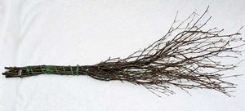
Withe: (pronounced why-th): branches used to tie together other branches; was sometimes used as a whip.

- Vocabulary Practice: Complete the chart

Read Part One
Definition in English | Word | Translation
 | whip
 | borrow
 | offered (offer)
 | janitor
 | climb
 | crowd
 | lizard
 | to charge
 | uphill
 | freezing (adj)
 | sweat (n)
 | fence
Basic Understanding Questions: Part One
- Answer the questions about Part One:
- What would happen to Dave if he got home late?
- Why did Dave have to sweep the floor, wash the blackboards and clean the windows?
- Describe the teacher - Professor Herbert.
- How did the cherry tree break?
- What time did Dave leave the school? How far did he have to walk?
- What was Dave's father doing when he finally got home?

- Complete the summary of Part One using the words below:
The boys left the ___________________ to ___________________ the cherry tree to catch a little ____________________. After the tree broke, Eif Crabtree ___________________ the boys six dollars for the tree. Dave couldn’t _____________________ a dollar to pay for the tree, so he asked the Professor to __________________________ him with a ___________________________ and send him home. Dave was disappointed that Professor Herbert didn’t ____________________ to lend him the dollar and so he had to stay and help the __________________________. On his way home, Dave ran ___________________________ in the ______________________ cold because he was late. The cold wind dried the __________________________ on his face. Dave saw his father doing his job and quickly opened the ____________________________.

whip, borrow, janitor, crowd, freezing, sweat, lizard, offered, climb, fence, charge, uphill
- Dealing with Dialect: Understanding Luster’s speech
Before reading Part Two, we need to take a look at the way the characters speak in this story.
Professor Herbert and Dave speak Standard English (the English you are also learning) at school.
Pa and Dave speak a different kind of English on the farm. This is called dialect, which is a regional form of speech. This English is more difficult for us to understand because it has a lot of slang, abbreviations (קיצורים) and different grammar.
Below is a mini-dictionary to help you understand what Pa is saying.

Luster’s Dialect | Standard English (the way we speak)
‘em | them
‘im | him
agin | against
ain’t | am/is not
allus | always
atter | after
fer | for
gettin’ (apostrophe) | getting
hep | help
hisself | himself
jist | just
larnin’ | learning
th’ | the
Note to the teacher: While you are reading the story aloud, stop when you reach one of these sentences, and discuss the meaning with the students. Have them paraphrase/translate the meaning in their own chart.
Luster’s speech | What we understand
"What in th' world has kept you so? Why ain't you been here to help me with this work? Make a gentleman out'n one boy in th' family and this is what you get! Send you to high school and you get too onery fer th' buzzards to smell!" | Why are you late? I send you to school and now you are too snobby to do your chores? OR  למה אתה מאחר? אני שולח אותך לבית הספר ועכשיו אתה "טוב" מדי לעשות מטלות בבית?
"Why are you gettin' in here this time o' night? You tell me or I'll take a hickory withe to you right here on th' spot!"
Don't they teach you no books at that high school? Do they jist let you get out and gad over th' hillsides?
Didn't do that, my son, when I's a little shaver in school. All fared alike too."
"Ashamed of your old Pap are you, Dave," says Pa, "atter th' way I've worked to raise you! Tryin' to send you to school so you can make a better livin' than I've made.
take a different kind of lesson down there and make 'im acquainted with it."
You'll get th' Law atter you. You'll jist go down there and show off and plague your own boy Dave to death in front o' all th' scholars!"
My boy is good as th' rest, ain't he? A bullet will make a hole in a schoolteacher same as it will anybody else.
bug larnin' and this runnin' all over God's creation huntin' snakes, lizards, and frogs. Ransackin' th' country and goin' through cherry orchards and breakin' th' trees down atter lizards!

Analysis and Interpretation: Part One
There is a proverb, "If you spare the rod you spoil the child."
- What do you think this means?
- Who says this?
- To whom does he say this?
- Explain why he says it.
- Is there a similar expression in your mother tongue?

- Glossed vocabulary: Part Two

English | Definition
scattering the bundles of fodder | פיזור חבילות אוכל לחיות
It split at the forks | התפצל בצמתי הענפים
galavant (also spelled gallivant) | לשוטט ולבלות
I would take a bundle of fodder, remove the hickory witheband from around it, and scatter it on rocks, clumps of green briers, and brush so the cattle wouldn't tramp it under their feet | הייתי לוקח את חבילת האוכל לחיות, מוריד את קשרי הענפים הרכים מסביב לחבילה, מפזר אותו על האבנים עם שיחים ירוקים נמוכים כדי שהבקר לא ירמוסו אותו מתחת לרגליהם.
pigpen | דיר חזירים
steer | פר
"I had to do all th' milkin' tonight, chop th' wood myself | הייתי חייב לחלוב את הפרות הערב ולחתוב את כל העצים לבד

Read Part Two

Basic Understanding Questions: Part Two
- Look up the words and write sentences using them so that they connect to the story.
  - moonlight-
  - slip(ped)-

- After reading, answer the following questions:
- Who is Eif Crabtree?
- What thoughts does Dave have after his talk with his father?
- What do we find out about the teacher Professor Herbert?
- What does Dave do after eating his supper?
- List the actions that Pa will take in school tomorrow in order to stand up for Dave.
  - ___________________________________
  - ___________________________________
  - ____________________________________
- What does Dave hope will happen to his Pa before he goes to school with him?

- Complete the chart: Who said this? To whom did he/she say it?
Quote | When | Who said? | To whom?
"Why are you gettin' in here this time o' night? You tell me or I'll take a hickory withe to you right here on th' spot!" | when Dave arrives home | Pa | Dave
“ I had to stay after school”
“We take a subject in school where we have to have bugs, snakes, flowers, lizards, frogs, and plants. It is biology. It was a pretly day today. We went out to find a few of these.”
“A bullet will go in a professor same as it will any man.”
"...you jist stay away from there. Don't cause a lot o' trouble. You can be jailed fer a trick like that.”
Analysis and Interpretation Questions: Part Two
- Answer the following questions:
- There are two important men in Dave’s life.
  - Name them.
  - Show how he respects and tries to understand both of them.
  - What values does he learn from each one?
- Both Pa and Professor Hebert demand that Dave take responsibility.
  - How are these responsibilities similar?
  - How are these responsibilities different?

Basic Understanding Questions: Part Three
- Glossed words: Look at the definitions of these words. You will see them in bold in your text.
Word | Definition
thaw | להפשיר
ditches | תעלות
sheepskin | עור כבש
slouched (adj) | עמד בצורה עצלנית
holster | נרתיק לאקדח
trudging | דשדוש
black-rimmed glasses | משקפיים שחורים
varmint | שרץ

- Dealing with Dialect: Understanding Luster’s speech
Luster’s speech | What we understand
“I don't like no sicha foolish way o' larnin' myself!"
“It's a lot in knowing the other fellow.”
“He said you's all out bug huntin' yesterday”
“the long blue forty-four and put his finger on the end of the barrel”
“This maul o' mine could do you up in a few minutes”
“You know that's dangerous, too, puttin' a lot o' boys and girIs out together like that!"
“all this swarm of youngins out to pillage th' whole deestrict. Breakin' down cherry trees. Keepin' boys in atter school”
“only a-larruped im with a withe”
“too big until they're over twenty-one”
“It don't look good to me nohow”

Vocabulary Practice: Part Three
Match the word to its translation.
boots | חוֹבָה
duty | כְּפוֹר
frost | רַב-עָצְמָה
mighty | סַרְבָּל
overalls | תַּלְמִיד
scholar | התרכך
softened | תלול
steep | מגפיים
Read Part Three

Basic Understanding Questions: Part Three
- Complete the paragraph with the words from the chart above.
In the morning, Dave saw the ___________________ on the trees that he knew the sunshine would melt during the day causing muddy water. Pa wore _____________________ and __________________________ and put his gun in the holder. Pa looked _________________________ next to Professor Herbert when he said that he wanted to make Dave smart like a ________________________. Professor Herbert explained to Pa that he is following the program of the State which he had to do because it was his ___________________________ as a teacher. Professor Herbert explained that the price of the tree was ___________________________, but that it was a good lesson. Pa ___________________________ and put his gun back under his coat.

- Answer the following questions:
- What does Pa tell Professor Herbert ?
- What does Professor Herbert explain to Pa ?

- Analysis and Interpretation: Part Three
- Special vocabulary:
There is an idiom, “I was shaking like a leaf in the wind.”
- What do you think this means?
- Who says this?
- To whom does he say this?
- Is there a similar expression in your mother tongue?
- What caused him to shake like a leaf in the wind?

Note to the teacher: We are using the Inductive Methodology to introduce Explaining Patterns. The Basic Understanding task below is included in the Analysis and Interpretation section because it sets up for the analysis task which follows it. The goal is to emphasize the daily patterns of the family’s life which will be elicited after the task.

- List the chores that are done on the farm every morning.

Ma | Pa | Dave

Answer the following questions:

- Do these chores occur every day?
- Why is it important to do these chores every day?
- What do we know about the family because of their behaviour every day?

Thinking about a higher-order thinking skill:
We have included additional scaffolding for your students who may need it at the end of this file in the Appendix (page 40 of these worksheets).

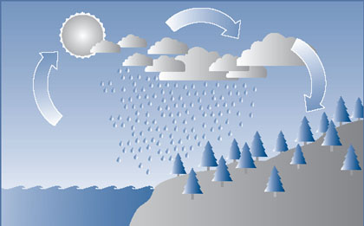
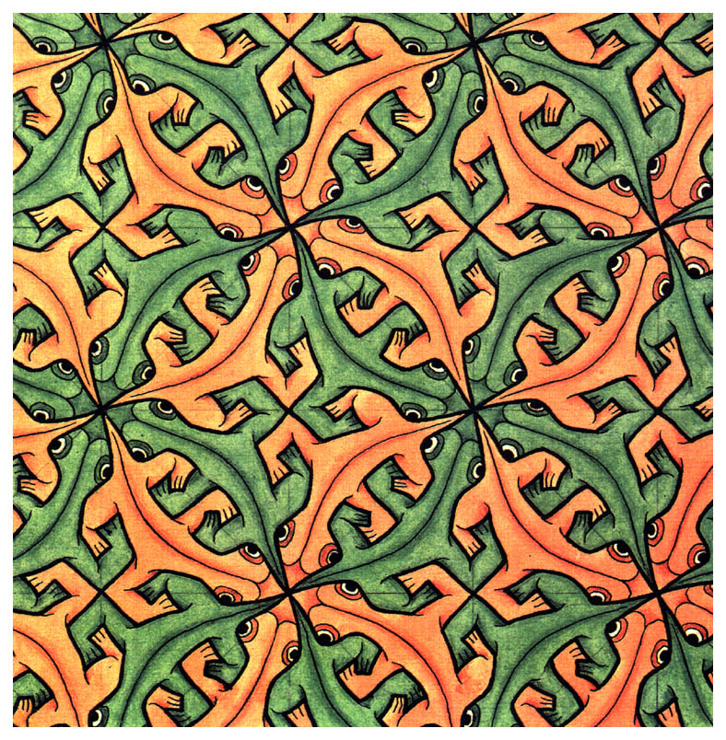

What do these two pictures have in common? What do they represent?
Looking at what we know about Dave’s family’s behaviour on the farm, and looking at the two pictures above, what can we say they all have in common?
{Elicit the name: Explaining Patterns (or just patterns) from them. Students may not know the word pattern in English and they may come up with something like 'things that repeat themselves' so guide them to the word pattern.}
We are using the thinking skill of Explaining Patterns. We can use it in the story and we can use it in our lives.
How else can you use the thinking skill of Explaining Patterns in your lives?

Analysis and Interpretation Questions: Part Three
- Both of Dave’s worlds now come together. What are his feelings and concerns about this?
- "Maybe Pa will find out Professor Herbert is a good man. He just doesn't know him. Just like I felt toward the Lambert boys across the hill. I didn't like them until I'd seen them and talked to them. After I went to school with them and talked to them, I liked them and we were friends. It's a lot in knowing the other fellow."
- How did Dave feel about the Lambert boys when he first saw them?
- How does Dave feel about them now?
- What experience changed the way Dave feels about the Lambert boys?
- How does Dave’s experience with the Lambert boys help him hope for a change in Pa’s feelings towards Professor Herbert?
- Based on Dave’s experience with the Lampert boys, predict a possible end to the meeting at school?
- Is Dave’s wish fulfilled? What words from the text support your answer?
Making Connections- Explicit HOTS Teaching





What do people use these websites for?
What is the connection/relationship between them?

When identifying and explaining these kinds of relationships we use a thinking skill called Making Connections. How else can we use Making Connections in our lives?
Application of Making Connections to the text:
Note to the teacher: The chart below, although it is a Basic Understanding task, appears here as a preliminary task to the Analysis and Interpretation questions below.
- Just as we looked at the three generations in our own family in the pre-reading activity, let’s examine the three generations represented by Pa, Professor Herbert and Dave.

 | Pa | Professor Herbert | Dave
Age (guessed)
Education
Job/Position/Work
Speech (Standard English/ dialect)

Use the chart above to explain the generation gap between:
- Pa and Professor Herbert
- Pa and Dave

Questions:
- Explain the connection between Professor Herbert’s education and his spoken English.
- How does Pa think that education will influence Dave’s future job?
- Describe Dave’s connection to both of his worlds (farm and school). How do you think he feels? Have you ever felt a part of two different worlds? Explain the situation and how you felt.
- Vocabulary Practice: Part Four
    - Look at the definitions of these words, you will see them in bold in your text.

Word | Translation
dry timothy grass | עשבים מיובשים
incubator | מדגרה
protozoa | חי חד-תאי
scum | ליכלוך
casual | לא פרומלי
dissect | לנתח, לבתור
leafless elm | עץ בוקיצה בלי עלים
buckskin | עור הצבי
baggy | מכנסיים רפויים
collar | צווארון
propositions | הצעות, היפוטזות
gray-streaked black hair | שיער שחור עם פסים אפורים
ripe fodder blade | להב שחותחים איתו את האוכל של החיות
gnarled | מיובל
geometry | גיאומטריה
prints (outlines) | משימות כתיבה

    - Dealing with Dialect
Luster’s speech | What we understand
“Th' incubator is th' new-fangled way o' cheatin' th' hens and raisin' chickens. I ain't so sure about th' breed o' chickens you mentioned."
“jist readin', writin', and cipherin'”
“Th' world's changin'”
“'Seein' is believin',' Pap allus told me.”

    - Match the word to its translation: (There is an additional activity for these words on page 38 of these worksheets).
Word | Translation
playground | שיניים
snake | מגרש משחקים
butterflies (butterfly) | נחש
blackboard | לוח בכיתה
toad | חיידק
teeth (tooth) | קרפדה
germ | פרפרים

    - Translate these words:
Word | Translation
dispute (v):
march:
grin:
ashamed (adj):
punch:
wrinkled (adj):
Read Part Four

Basic Understanding Questions: Part Four
- Complete the summary of Part Four with the words from the two activities above:
Professor Herbert explained that the students hunted _______________, ______________ and _________________________. Professor Herbert told Pa that he had ________________ on his ___________________. Pa was surprised by Professor Herbert’s explanation of germs but he did not ______________________ him. When the other students _______________________ into the schoolhouse and saw Pa, they _____________________ and ____________________ each other. Pa’s overalls were ______________________ and baggy. Dave watched Pa standing beside Professor Herbert. During class, Professor Herbert had the students write on the ___________________. Dave saw Pa and Mr. Herbert in the _________________________. He wouldn’t be ____________________ of Pa as long as he ____________________ and didn’t use the gun.

- Questions:
- Professor Herbert wants to show Pa that school has changed.
- What did Pa learn at school?
- What new subjects does Pa see Dave is learning at school?
- Professor Herbert introduces Pa to the idea of germs. How does Pa react to the idea?
- Dave notices how the other students see his father. List at least three things that they notice in class and in the cafeteria.

Analysis and Interpretation Questions: Part Four
- “They ate together. The students watched the way Pa ate. He ate with his knife instead of his fork. A lot of the students felt sorry for me after they found out he was my father. They didn't have to feel sorry for me. I wasn't ashamed of Pa after I found out he wasn't going to shoot Professor Herbert.”
  - Why do Dave’s friends feel sorry for him?
  - Why wasn’t Dave ashamed of Pa?

- “Th' world's changin'."
"It is," says Professor Herbert, "and we hope all for the better. Boys like your own there are going to help change it. He's your boy. He knows all of what I've told you. You stay with me today."
- During Pa’s visit, he realizes that the old world has changed. In what way is Pa curious about the changes that he sees?
- What does Professor Herbert hope to achieve by showing Pa around the school all day?

- “He would find out about the high school as I had found out about the Lambert boys across the hill.”
- When Dave first thought about the Lambert boys, he wanted Pa to get to know Professor Herbert. What does Dave want Pa to get to know now?
- In what way is this similar to “there’s a lot in knowing the other fellow” from Part II?

    - Glossed Vocabulary Practice : Laboratory – מעבדה
Here is a glossary of the words. We have included additional scaffolding for your students who may need it at the end of this file on page 39.
Word | Translation
stool | שרפרף
microscope | מיקרוסקופ
scrape | לגרד
tartar | עששת
lens | עדשה
chloroform | כמיקל שמשתמשים במעבדה כדי להרדים חיות לפני ניתוחים

Read Part Five

    - Dealing with Dialect
Luster’s speech | What we understand
You're right certain they ain't no fake to this
mousers | animals that can catch and kill mice
I don't allow 'em killed on my place."
Man can defend hisself," says Pa, "but cattle and mules can't. We have the drop on 'em. Ain't nothin' to a man that'll beat a good pullin' mule. He ain't got th' right kind o' a heart!"

Vocabulary Practice: Part Five

Choose the correct Hebrew translation for the word in bold.
Look for the word in bold | Choose the correct Hebrew translation for the word in bold
Professor Herbert adjusted the microscope for Pa. | להראות, להתאים, להזיז
To see in the microscope, Pa had to squint his eyes. | לעצום עיניים חלקית, לעצום עיניים, להביט
Some germs are harmful to our bodies. | עוזרים, מזיקים ,משנים
The handle of his gun showed under Pa’s coat. | קנה, הדק, ידית
The laboratory was filled with expensive equipment. | ספרים, ציוד, רהיטים
The students’ voices were louder during recess. | חזק יותר, חלש יותר, שקט יותר
Dave used the broom to sweep the room. | מקל, מטאטא, מגב  לטאטא, לשטוף, להכות
Basic Understanding Questions: Part Five

- How does Professor Herbert teach Pa about the germs?

Put the actions in the right order:
Events | Sequence order
Pa asks Professor Herbert not to kill the snake.
Pa looks in the microscope.
Professor Herbert adjusts the microscope.
Pa and Professor Herbert continue on to see the rest of the laboratory.
Pa sees germs through the microscope.
Professor Herbert scrapes tartar off of Pa’s teeth.
Professor Herbert goes to get a black snake to dissect.
Professor Herbert tells Pa to squint one eye and look in the lens of the microscope.

Analysis and Interpretation Questions: Part Five
Application of Explaining Patterns (re-enter) to the text:
Put the sentence in order according to the text.

Events | Sequence order
Dave says “He knows about his gun and he knows he doesn't have any use for it in high school.”
Pa puts his gun on the table when he first meets Professor Herbert.
Pa threatens to whip Dave because he is late.
Pa doesn’t want Professor Herbert to kill the black snake.
Pa says boys can be whipped until they are 21 years old.
In the laboratory, Pa realizes his gun is sticking out of his coat and pulls the coat over the gun.
Pa gets angry with Professor Herbert’s punishment and says he will come to school with his gun and make it alright.
“Pa’s face gets a little red”
Pa takes his gun to school to threaten Professor Herbert.
When we learned about the thinking skill Explaining Patterns, we also talked about patterns in a character’s behaviour.
- How would you describe Pa’s pattern of behaviour up until he enters the laboratory?
- Read the quote from Part V:
“His coat slips up behind when he bends over. The handle of his gun shows. Professor Herbert pulls his coat down quickly.
"Oh, yes," says Pa. He gets up and pulls his coat down. Pa's face gets a little red. He knows about his gun and he knows he doesn't have any use for it in high school.”
Look at the highlighted sentence.
- What has Pa understood all of a sudden that makes his face go red?
- This sentence is a turning point for Pa and his pattern of behaviour. How does Pa’s new understanding break his old pattern of behaviour?
- Other Analysis and Interpretation Questions
- In Part One of the story, Dave was afraid what would happen when his father came to school. Now that Pa is at school, what does Dave realize about:
  - Himself
  - His father
  - Professor Herbert

- The students look at Pa. They seem to like him better after he said that. Pa with a gun in his pocket but a tender heart beneath his ribs for snakes, but not for man!
- Why does Dave think the students like his father better now?
- What does Dave thinks about his father now?
- What do you, the reader, think about Luster now?

- “He looked like a leaf turned brown on the tree among the treetop filled with growing leaves.”
- Who is Dave speaking about?
- What does Dave mean by this?

Vocabulary Practice: Part Six
- Glossed vocabulary
Word | Translation
remedy (ies) | תרופות
warrant (n) | צו מעצר
pistol | אקדח
Read Part Six

- Dealing with Dialect: Understanding Luster’s speech
Luster’s speech | What we understand
I'm a dead leaf, Dave. I'm behind
I'll hep you pay it. I'll ast 'im and see if he won't let me hep you."
we're just and honest people. We don't want somethin' fer nothin'
I don' skip debts. I ain't larned 'em to do that. I ain't got much larnin' myself but I do know right from wrong atter I see through a thing."
"I can't sweep. Durned if I can. Look at th' streaks o' dirt I leave on th' floor! Seems like no work a-tall fer me. Brooms is too light 'r somethin'. I'll jist do th' best I can, Dave. I've been wrong about th' school."

Basic Understanding Questions: Part Six
- Why does Professor Herbert want to cancel the debt? Find the words in the text where he explains this.
- Why doesn’t Pa want to let Professor Herbert cancel the debt? Find the words in the text where he explains this.
- What does Pa do to help Dave pay his debt? Is it easy for him? Explain.
Analysis and Interpretation Questions: Part Six
We have included additional scaffolding for your students who may need it at the end of this file in an Appendix (page 41).
- Read the following quote:
“You must go on to school. I am as strong a man as ever come out'n th' hills fer my years and th' hard work I've done. But I'm behind, Dave. I'm a little man. Your hands will be softer than mine. Your clothes will be better. You'll allus look cleaner than your old Pap. Jist remember, Dave, to pay your debts and be honest. Jist be kind to animals and don't bother th' snakes. That's all I got agin th' school. Puttin' black snakes to sleep and cuttin' 'em open."
According to the quote, compare what Pa’s life has been until now and what Pa sees for Dave in the future.
Teacher’s note: This Basic Understanding activity is a preliminary activity to the Analysis and Interpretation which follows it.
- Complete the chart describing the two evenings at home: Use the phrases and actions from the bank below:
Take care of animals, take care of the farm, do chores, Ma makes supper, The family eats supper, Dave does his schoolwork, Pa tells Ma he would like to take her to school to see germs, Pa tells Ma that he is going to shoot Professor Herbert, Dave runs home alone, Pa and Dave walk home together, Dave is afraid of being late, Pa thinks Professor Herbert was unfair with his punishment, Pa thinks Professor Herbert has a lot to teach Dave, Pa thinks what Dave studies in school is nonsense, Pa thinks what Dave studies in school is important

Complete the chart describing the two evenings at home:
First evening | Second evening
Now, answer the questions based on the chart above.
- What do you think was the most important reason for the difference in the two evenings at home?
- What happened to the regular pattern of Dave’s home life on this second evening? Explain.
More Analysis and Interpretation Questions – Part Six
- Remember we discussed the generation gap in the pre-reading activity. What does Pa realize about the path that Dave is going to take in his life and how it differs from his own?
- Why is the story called “The Split Cherry Tree”? What is split besides the tree?

Bridging Text and Context Activity
Answer one of the questions.
- Robert Penn Warren (another American author), said that Jesse Stuart’s stories deal not only with situations that show human warmth and toughness, but also show violence and brutality, yet his stories also have some humor that is based on all these qualities.
(Adapted from the Introduction to The Best Loved Stories of Jesse Stuart, by Jerry A. Herndon, 2000).
How does this general comment about Jesse Stuart’s writing relate to the story “The Split Cherry Tree”, and help you understand it better?
- How do these photos of Kentucky in the 1930’s help you understand the character of Pa in the story?
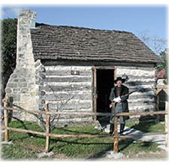
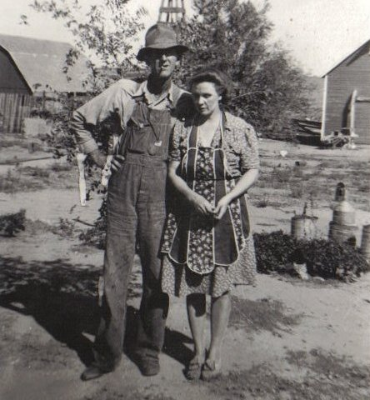
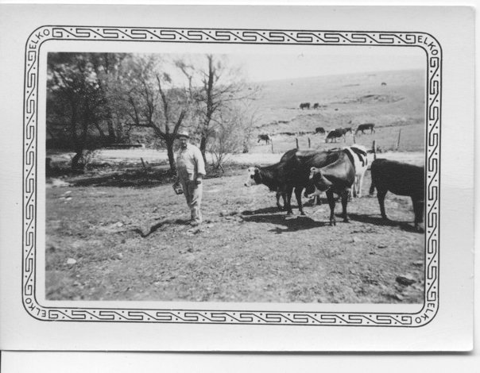
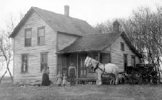

Post-reading Activities
Choose one.
- After Dave finished high school, what does he decide to do? Write a letter to Professor Herbert from Dave 10 years later.
- Draw the three main characters (Dave, Pa, Professor Herbert). Choose your setting, and pay attention to dress and props. Write a few sentences describing each of the characters. Present the drawing to the class and explain why you drew them that way.
- Write and perform an enactment of the meeting between Pa and Professor Herbert at Dave’s graduation.
- Tell the story as Professor Herbert might have told it to his wife.

Reflection

The HOTS we learned with this story are:
- Making Connections
- Explaining Patterns

- Reflect on how learning to be aware of these higher-order thinking skills can help you in your daily lives.
How can you use Explaining Patterns in your own lives? ____________________________________________________________________________________________________________________________________________________________________________________________________________________________________________________________________________________________________________________________________________________________________________________________

How can you use Making Connections in your own lives?
____________________________________________________________________________________________________________________________________________________________________________________________________________________________________________________________________________________________________________________________________________________________________________________________

- Choose the activity or assignment you liked doing the best and explain why.
________________________________________________________________________________________________________________________________________________________________________________________________________________________________________________________________________________________________________________________________________________________________________________________________________________________________________________________________________

Appendix for students who need more scaffolding

Pre-reading Activity

If you wish, you may choose to use the family tree to further portray the generation differences before completing the survey and answering the questions.
Vocabulary – Part I
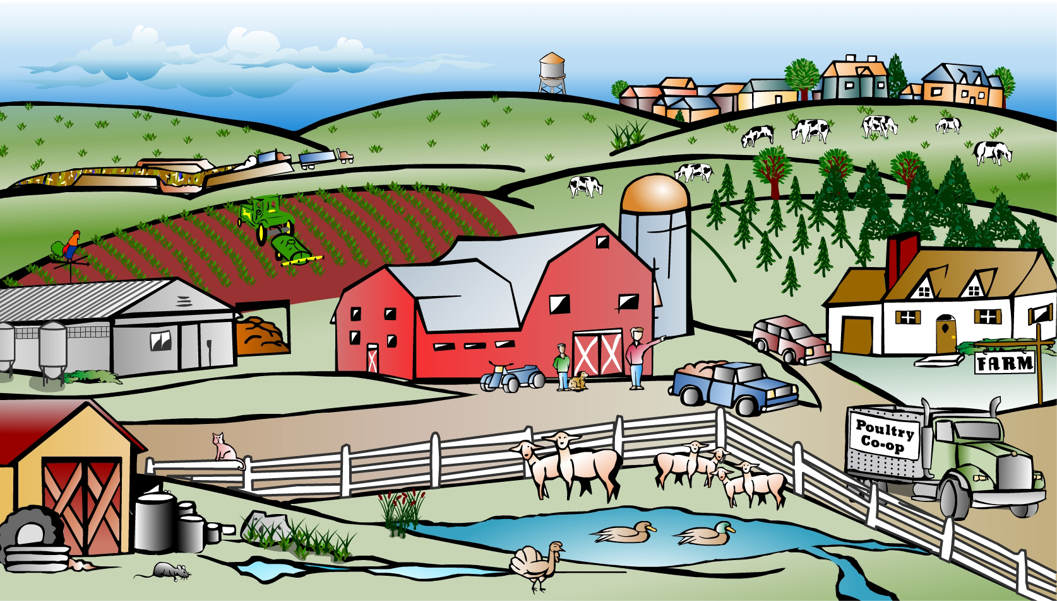


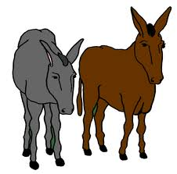
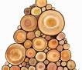
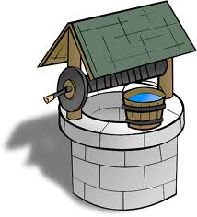
Instead of using the glossed vocabulary chart in Part I, you can have the students label the photo with the words in the chart.

- Label the pictures on the farm with the words below. These will help you understand the first part of the story which takes place on a farm.
Word | Definition/Translation | Things you can find in the picture
switch | knife, blade
plowing |  | X
head of cattle | number of cows
mules |  | X
hogs |  | X
firewood |  | X
stovewood |  | X
to draw from the well |  | X
ridge |  | X
cow pasture |  | X
chipyard | pile of small pieces of wood leftover from chopping wood
barn |  | X
spread fodder |  | X (pile of fodder)
fence |  | X
Vocabulary Practice- Part IV
You can use this to illustrate the vocabulary words which are glossed in a chart in the worksheets.

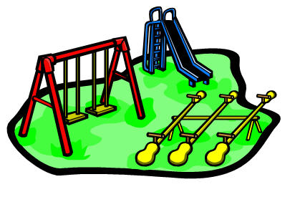




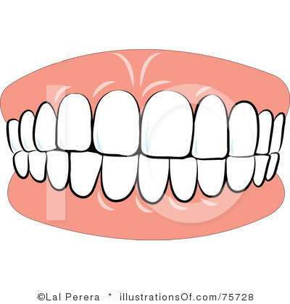
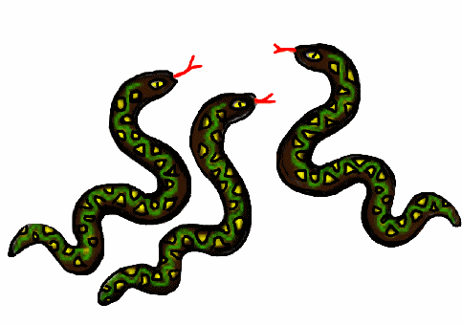

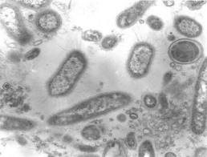

germs, teeth, toad, blackboard, butterflies, snakes, playground,

Glossed Vocabulary Practice: Part V
Laboratory - מעבדה
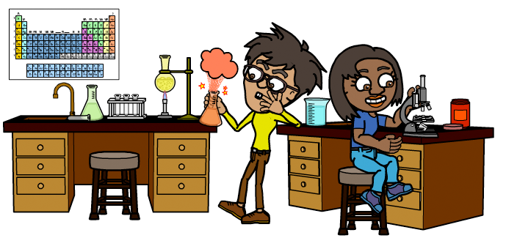
You can use this picture to illustrate glossed laboratory vocabulary.

Write the words in the correct place in the picture.
Word | Translation | Things you can find in the picture
stool | שרפרף | X
microscope | מיקרוסקופ | X
scrape | לגרד
tartar | עששת
lens | עדשה | X
chloroform | כמיקל שמשתמשים במעבדה כדי להרדים חיות לפני ניתוחים | X

This is the explicit HOTS teaching of Explaining Patterns with scaffolding for students who may need it.
Picture A Picture B

Do you remember how it rains? Where does rain come from?  - Look at Picture A above.  - List the stages you see above. You can begin at any stage.  - What happens after the last stage?  Rain and water evaporation (התאדות) is a pattern in nature.  Rain will always come down, it will be heated by the sun and evaporate and then clouds will form and make rain come down again, which will be heated by the sun…..etc. | Have you ever seen an Escher painting?  Look at the Picture B.  What do you see?  Can you tell where the painting begins and where it ends?  Can you count the lizards in the painting?  If the painting were larger, could you guess how it would continue?

Based on what we have seen about Luster and his family’s behavior and based on these two pictures above, can you guess what they have in common?
This is called Explaining Patterns. We can see patterns in behavior, in nature and in art. How can the thinking skill of Explaining patterns be used in your lives?

Analysis and Interpretation Questions: Part Six
- Read the quote:
“You must go on to school. I am as strong a man as ever come out'n th' hills fer my years and th' hard work I've done. But I'm behind, Dave. I'm a little man. Your hands will be softer than mine. Your clothes will be better. You'll allus look cleaner than your old Pap. Jist remember, Dave, to pay your debts and be honest. Jist be kind to animals and don't bother th' snakes. That's all I got agin th' school. Puttin' black snakes to sleep and cuttin' 'em open."
List the things Pa says about himself and what Pa says about Dave in the future.
Pa | Dave

According to the quote, compare what Pa’s life has been until now and what Pa sees for Dave in the future.

