*Saturday Sep 23, 2017. Editor: Shiraz Ben Hamo*

***Happy event:***

*My Bat Mitzvah was a very special and fun event. All my family and my friends came. We enjoyed it very much.*

*First of all, I would like to tell you about myself, my name is Shiraz Ben Hamo and I am 15 years old.*

***My family:*** *My parents- my dad, Gabi is 44 years old. My mother, Valerie is 43 years old. My dad owns an event hall and my mother works at a kindergarten.*

*My sister's names are- Dorin is 17 years old, Maya and Noya are 7 years old. They are twins.*

***My dream:***

*My dream is to work in the Hi-Tech industry.*

*But first, to study in the Technion or university. It is very important for me and I hope that I will do it.*



***My favorites:***

*Country- Israel*

*Food- pizza*

*Star- Maluma (He is a singer).*

*Animal- I don't like pets.*

*Sport- swimming.*



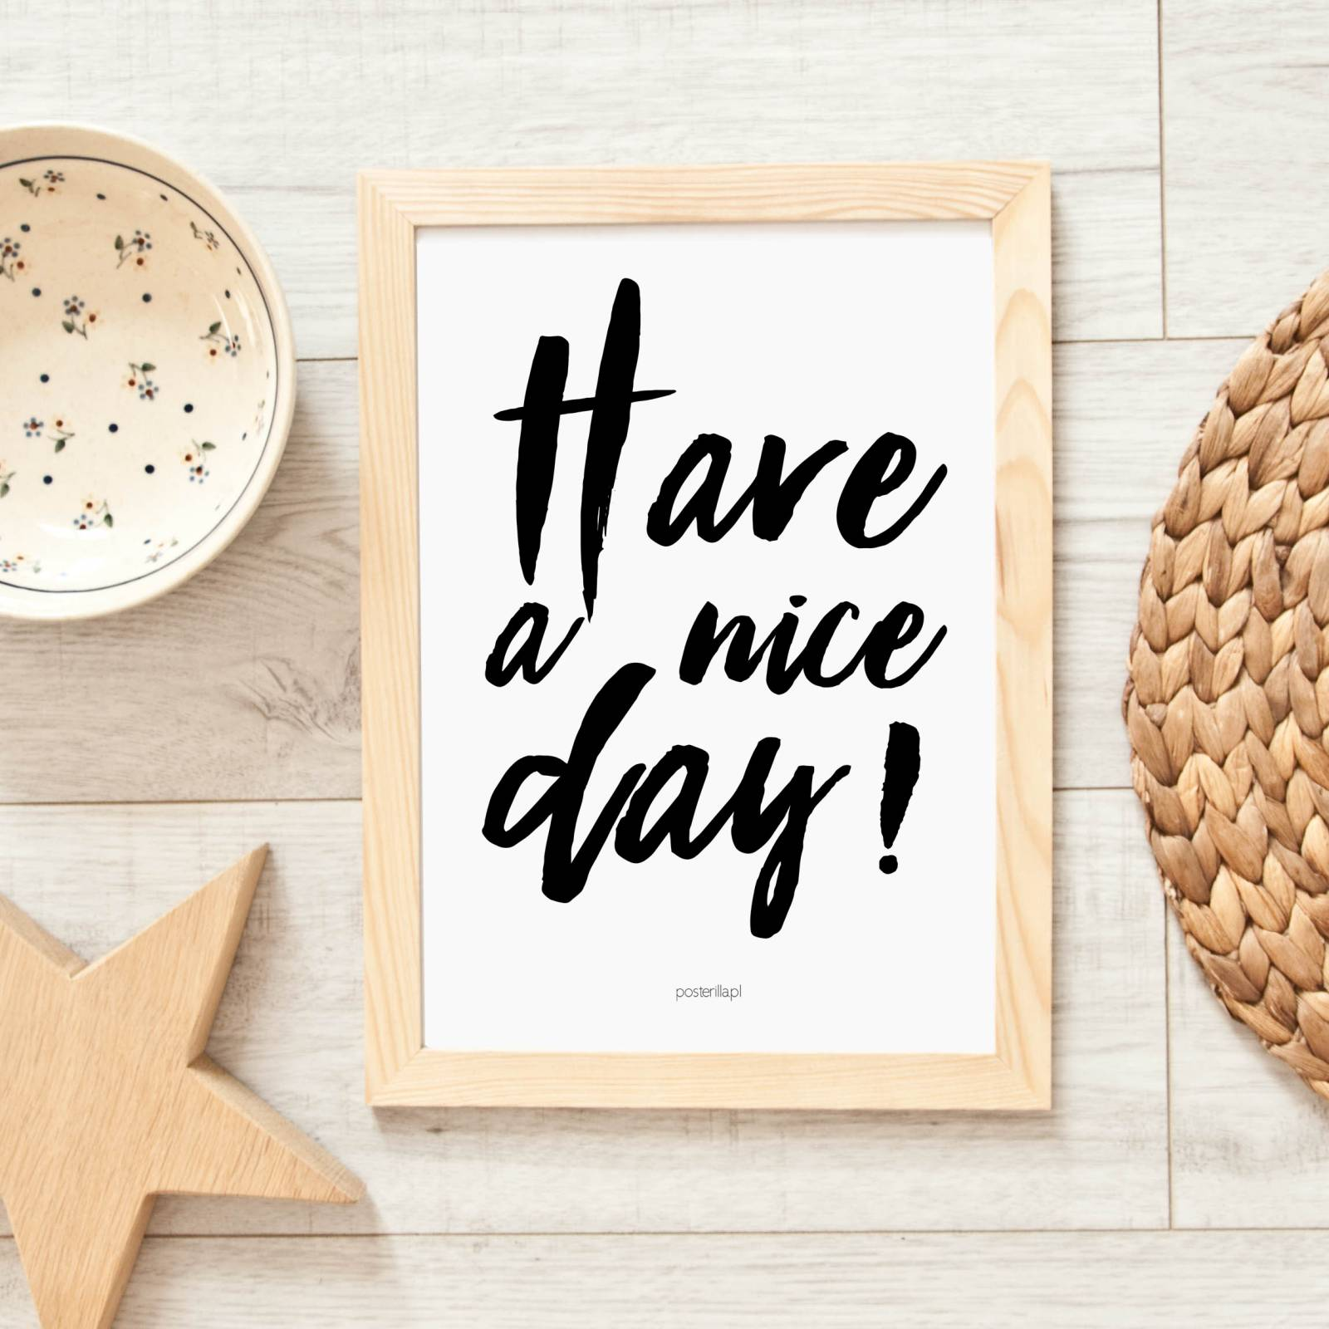

**My *friends* :**  *I have a few friends like: Liel, Ofri, Jasmine and Noa. We like go to movies , watch TV, talk and go to restaurants. We are all in the same class.*

***Why did I got my name?***  *My mother (Valerie) liked this name and wanted me to have it, I think it is a special name.*