Post Reading: The Split Cherry Tree
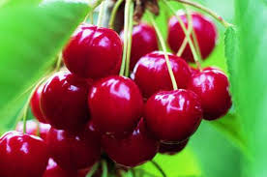
Dear students, The task for the short story "The Split Cherry Tree" Please choose one of the following tasks .
Post – Reading Tasks 100 words Choose ONE
1) Write a Dialogue between Luster and his wife, in which he describes the day he spent at the school.
2) After Dave finished high school, what does he decide to do? Write a letter to Professor Herbert from Dave 10 years later.
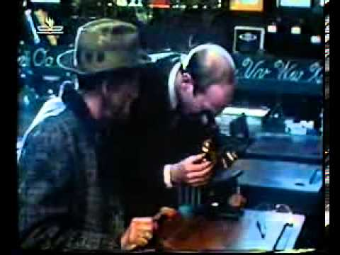
3) Tell the story as Professor Herbert might have told it to his wife.
4) Write a different end to the story.
5) Since the story deals with father son relationship interview your father .Tell him the story and ask him questions related to it and to the way school has changed from his day. You may want to ask him how he would handle the same situation as Pa had to.
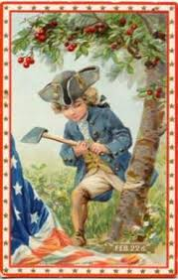
6) Write a page in one of the character's diaries.
7) Use a modern day setting using social networks like Facebook, Twitter,What'sApp etc. to retell or relate to the story.
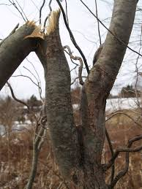
8) Write a comic strip about the story.
Reflection Do all of them. 50-70 words total in all 3.
- Did you like the story? Why or why not ?Explain your answer in at least three sentences.
- What did you find interesting about this story?
3. What did you learn from reading the story?

