My Role Model Ariel Sharon
By Shahar Sharvit
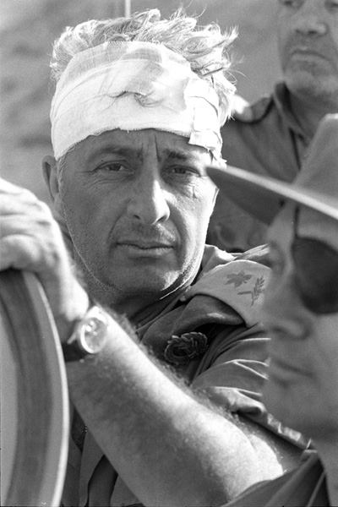
My role model is Ariel Sharon who showed lots of Courage and self confidence when he fought for our country in many wars with no fear, just so we can live here safely today he also put our country in his first priority trying to make it better financially and in Terms of security. Ariel Fought the War of Independence more over he was wounded by a bullet that pierced his stomach in Latrun. In the early 50s he founded the commando "Unit 101" a unit which Israel was established for on August 5, 1953 for implementation of reprisals in response to numerous intrusions of infiltrators from Jordan more over he the Gaza Strip to Israel, penetrations made for the purposes theft and murder. Paratroop brigade commander in the Sinai Campaign was commander of the Mitla Pass battle. In the Six Day War was acclaimed for the battles waged Um more over the Abu Ageila shoulder. Terrorism ruled the Gaza Strip early 70s GOC Southern Command. In Yom Kippur War with his Division crossed the Suez Canale what brought to a major turning point in the war.

