My Own Newspaper.
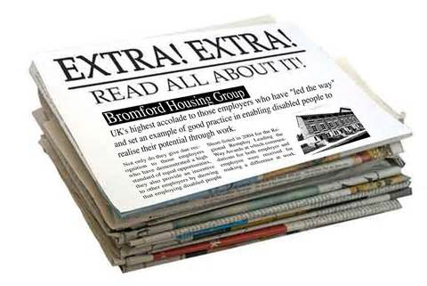
Hand in on _____________
Write between 3-4 pages about yourself
- .Choose a name that reflects your own name.
- Write a price , editor's name, and date.
- All the information must be public because we will hang it in class .Don't write things you don’t want people to know.
You may write about the following :
- Childhood memories.
- My hobbies
- Future plans
- My dream
- Interesting facts about myself.
- An interview with someone you admire.
- An imaginary article / invention you dream of making or just want to have one.
- A book/ TV show/ Movie review and/or recommendation.
- A trip you took or one you are planning,
- An article about yourself winning a prize you want.
- An opinion essay about something that matters to you.
Other options:
- Add advertisements for products or services you can supply.
E.g A babysitter / a food you prepare well, homework help for kids etc.
- For a bonus you may prepare a PowerPoint presentation or a video clip to be used in your speech in class.
- You can do a cover page with short sentences about each article and include a page number.
- Puzzles like crossword or search a word in which the clues are about you.
You can use websites that create them . Look for crossword maker on Google.
The Speech. We will start after Passover .
I will let you know the date.
You may present yourself using the newspaper or speak
about anything else .Time frame – 5 minutes. It's a separate grade.
Any special effort beyond these requirements will get you a bonus.
Good Luck! Ayelet

