Best News in town

h

Today, I’m going to interview Maya Shriki. She is sixteen years old and she studies at “Ort Bialik School”.
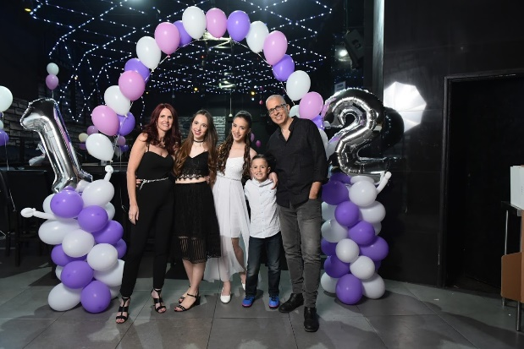
Tell me about your family and your friends.
“I have a wonderful family and great friends.
First, I’ll tell you about my family.
Maya’s family.
I have one brother and one sister.
The two of them are younger than me. We are good siblings.
Although we may argue a lot, we still enjoy spending time together and we love to be with each other more than anything!”

Sounds like an amazing connection! Now, tell me about your friends. I’m sure you have a lot.
“Yes. I have the best friends you could ever think of!
My best friend is Inbar.
Inbar and I have been best friends for 12 years.
We’ve known each other since kindergarten, which was a long time ago…
I think that nobody has a friendship like we have.
We always think about each other. We never fight, just argue, and we are together all the time.
I’m so glad to have her and I know that I can always trust her.
Now, I’ll tell you about my second best friends.
Their names are: Hila, Dvir, Daniel, Shira and Tal.
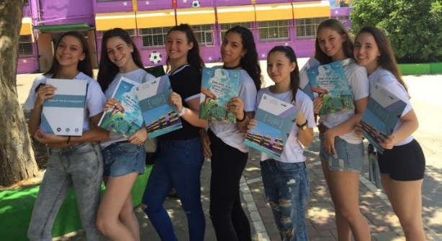
We all have a group that is called ‘The Bitches’ (of course Inbar in this group too). I know that it is a little bit rude but this is our name.”

A picture from last day in junior high school- ‘Ort Afek’.
Maya and her group- “The Bitches”.
“We have had this group for 3 years and I hope it will last forever.
We always tell each other everything, we tell jokes and send funny photos.
We feel so comfortable with each other and it makes us feel good.”
So, what are your hobbies?
“I have one main hobby and it is dancing.
I’m in a studio called ‘Studio Freestyle’. I really enjoy dancing there because there is always a good atmosphere there.”
I asked Maya to let me if she had a happy event or something special that she has recently done.
“Yes! In the last summer vacation,
I flew to Thailand! This country is the most beautiful country I have ever seen. I flew with two friends of mine, Inbar and Orin.
Orin is a childhood friend of me and I have known her for many years!
Of course their families flew with us too.
When we got there, I was in shock because the view was so incredible that I can’t even describe it with words!
I was so excited and couldn’t believe I was really there. It has been the most wonderful and relaxing experience I have ever had in my life! It was great fun. I’m so glad and blessed that I had the opportunity to experience it especially with my lovely friends.”
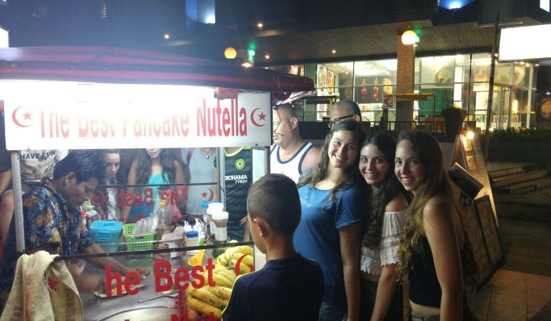

It sounds so good
Maya, Inbar and Orin in Thailand, Koh Samui.

That makes me think about this vacation for myself too, hahaha.
I must hear about your future plans, I’m sure you have some.
“My main dream is to be a ‘computer engineer’.
I think I have always wanted to work in this field but in recent years it got stronger because I got older and started to think about my future.”
So, do you also study computers in school?
“Yes, of course and I really enjoy from this.
I also learn physics in this trend and in my opinion it is very interesting.
I am happy I could choose to learn something interesting that might even be part of my future.”
That’s how my interview with Maya ends. I had fun interviewing her and I was glad to know her.

This is how Maya looks today.

