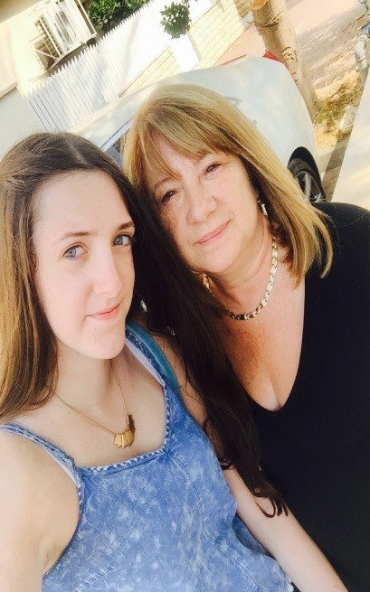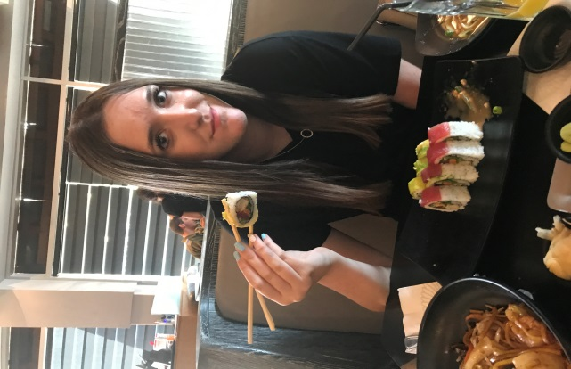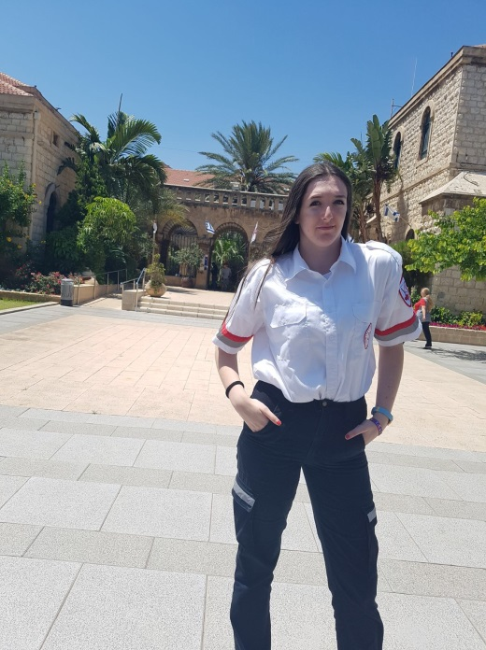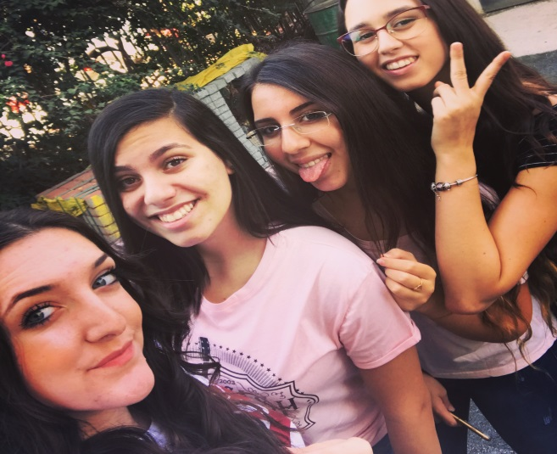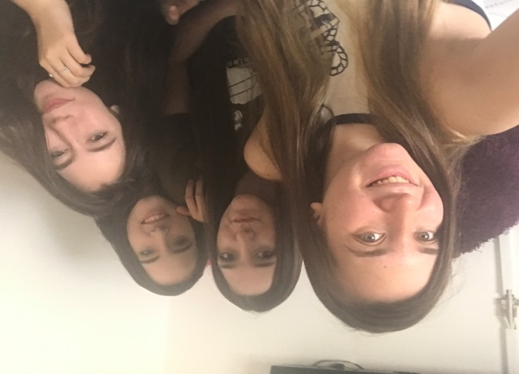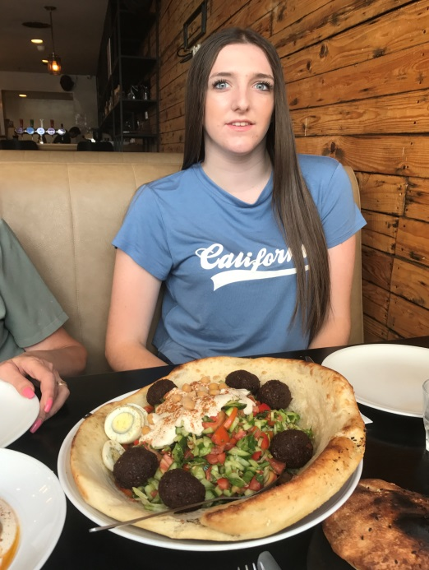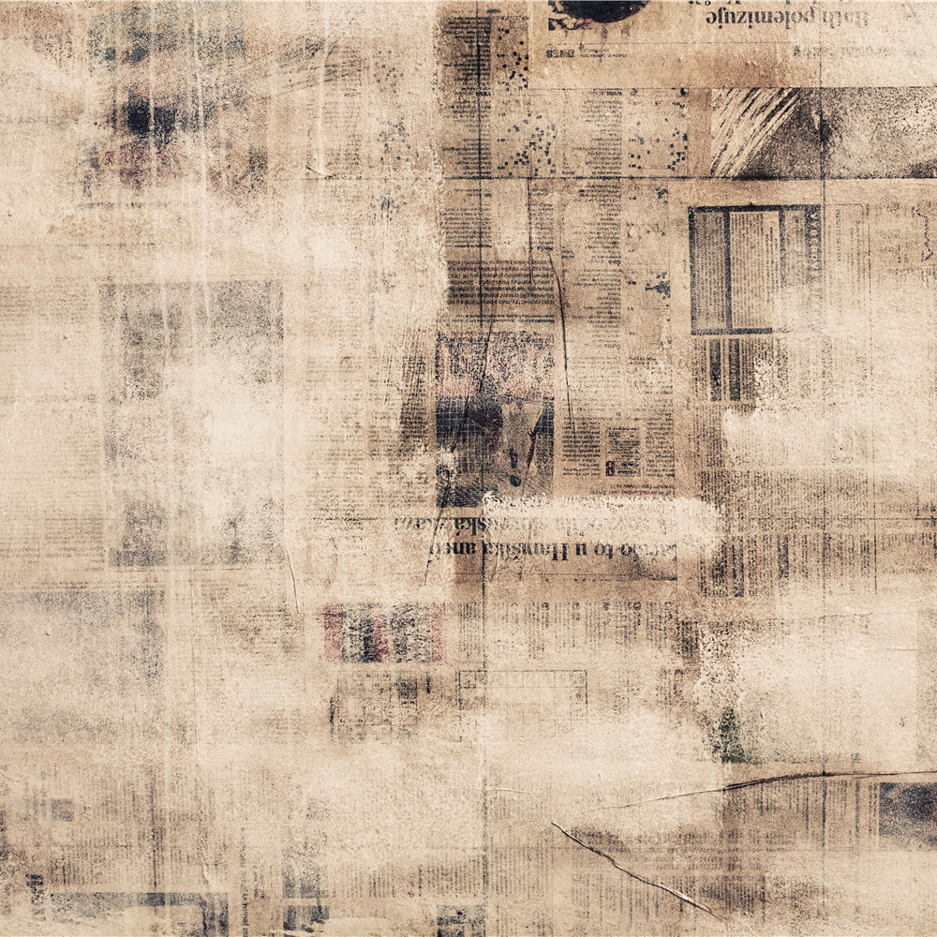

**An experience I remember**

**It was a trip girls planned to do once my grandmother felt better, during the trip we visited all over Budapest and of course we did shopping but most importantly we were together like three best friends.**

**"Hi, my name is Gabi and I am 16 years old from Kiryat Bialik. I study at "Ort Afek" and my hobbies are to spend time with friends and volunteer in MDA. Volunteering in MDA is my second home and a small step on the way to becoming a doctor":.**

**About family and friends**

**"I grew up as a single child. We are a small family without brothers and sisters, and yet I never felt lonely. On the contrary, this only brought me closer to my parents and to my friends, who are my sisters in every way, our favorite thing is to eat sushi that is my favorite food"**

**About myself..**