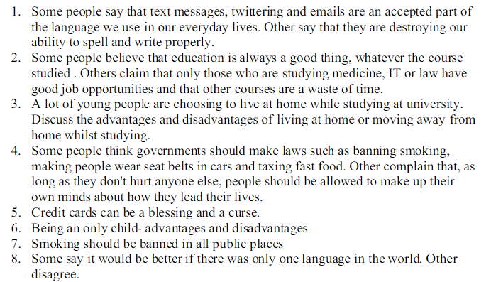
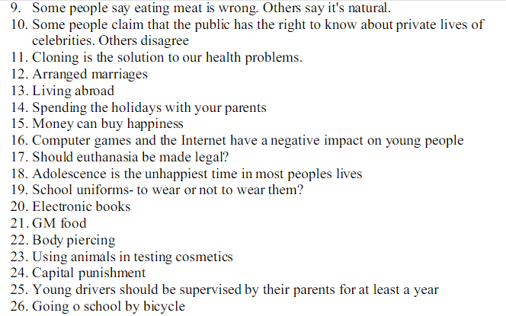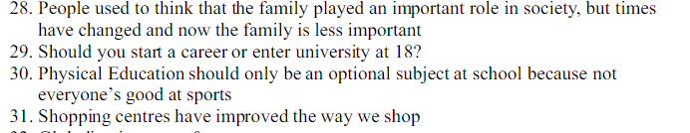
- Zoos are sometimes seen as necessary but not poor alternatives to a natural environment. Discuss some of the arguments for and/or against keeping animals in zoos.
- Imaginethat your teacher wants to teach a new subject for the next few weeks. Your teacher will take suggestions, and then let the students vote on the new subject. What subject should your class choose? Write an essay to support your choice and to persuade the other students to vote for your choice.
- Are actors and professional athletes paid too much?
- Should teachers have to wear uniforms or have a dress code?
- Since the invention of nuclear weapons we have had a long period of GLOBAL peace and stability. Are nuclear weapons global peacemakers or killing devices?
- Should boys and girls be in separate classes?
- Is the death penalty effective?
- To what extent is the use of animals in scientific research acceptable?
- What age is appropriate for dating?
- Pretend you woke up one day and there were no rules. People could suddenly do whatever they wanted! Explain what the world would be like. Use your imagination!
- Should student’s textbooks be replaced by notebook computers?
- Should students be allowed to have cell phones in elementary and high schools?
- Should wealthy nations be required to share their wealth among poorer nations?
- Should money be spent on space exploration?
- Is fashion important?
- Are we too dependent on computers?
- Ifyou had the opportunity to bring any person — past or present, fictional or nonfictional — to a place that is special to you (your hometown or country, a favourite location, etc.), who would you bring and why? Tell us what you would share with that person
- Most high level jobs are done by men. Should the government encourage a certain percentage of these jobs to be reserved for women?
- Should students be allowed to grade their teachers?
- In your opinion what factors contribute to a good movie?
- The destruction of the world’s forests is inevitable as our need for land and food grows. Do you agree?
- Many parents give their children certain chores or tasks to do at home. Should children have to do chores or tasks at home? Be sure to explain why you think it is a good idea or a bad idea. Include examples to support your reasons.
- Should the voting age be lowered to thirteen?
- Should the government place a tax on junk food and fatty snacks?
- Should more be done to protect and preserve endangered animals?

