Coldplay Lyrics
"Miracles (Someone Special) " (with Big Sean)
Discussion
- What do your parents tell you about school and success? What did they tell you before the beginning of this school year? – Write 3 sentences and share with a friend
- What do you tell yourself and how do you think it affects your success in school and in life in general?
- Read the lyrics and highlight the names of the famous people mentioned.
Do you know them? If you do write what you know about them
- What is the message of the song?
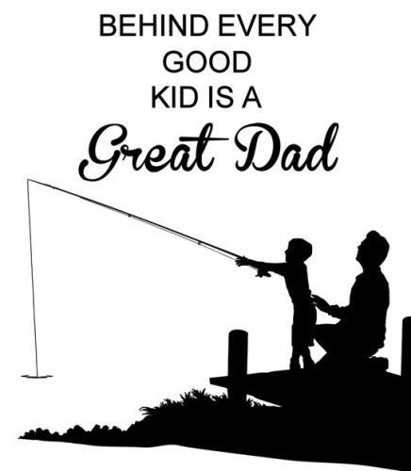
Vocabulary
- Lightning
- Veins
- Tuition
- Funds
- Insufficient
- Get a degree
- 401k
- Complacent
- Oasis
- on the verge of
Follow up after listening.
- Look up the names of the famous people mentioned and write about 3 lines on each one of them.
- What do they have in common and why do you think they were chosen for this song?
- How does their choice fit into the message of the song?
- Write sentences using the new words

Coldplay "Miracles (Someone Special) " (with Big Sean)

Songwriter(s) Guy Berryman Jonny Buckland Will Champion Chris Martin
link to the video
https://www.youtube.com/watch?v=z9BPMjL44Aw
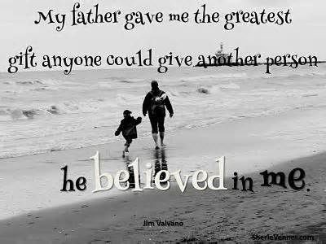
[Chris Martin:]
My father said never give up son
Just look how good Cassius become
Muhammad, Mahatma, and Nelson
Not scared to be strong
Now you could run and just say they’re right
No I'll never be no one in my whole life
Or you could turn and say no wait they're wrong
And get to keep on dancing all life long
My father said never give up son
Just look what Amelia and Joan done
Or Rosa, Teresa their war won
Not scared to be strong
Now you could run and just say they’re right
No I’ll never be no one in my whole life
Or you could turn and say no wait, they’re wrong
And get to keep on dancing all life long
Yeah you could be someone special
You've got bright in your brains and lightning in your veins
You'll go higher than they've ever gone
In you I see someone special
You've got fire in your eyes and when you realize you'll go further than we've ever gone
Just turn it on
[Big Sean:]
Look I paid my intuition I couldn't afford tuition
My funds was insufficient, it felt like I'm in prison
Until I realized I had to set my mind free
I was trusting statistics more than I trust me
Get a degree, good job, 401k, but I’m trying to turn k’s to m’s, what does it take?
And maybe I could be the new Ali of music prolly
Instead of doing it just as a hobby like these boys told me to
I guess you either watch the show or you show and prove
Prove it to them or you prove it to yourself but honestly it's better if you do it for yourself
Never complacent till we hit the oasis
One life don't waste it feel my heart races, success I taste it, ah
Ah we on the verge of getting every single thing that we deserve
[Chris Martin:]
Yeah you could be someone special
You've got fire in your eyes I see heaven inside you'll go further than we've ever gone
In you I see someone special
You've got bright in your brains you can break through those chains you'll go higher than we've ever gone
Just turn it on
In you I see someone special
Don't go to war with yourself
Just turn, just turn, just turn it on and you can't go wrong
A link to inspirational father quotes
https://www.google.ca/search?q=father+and+son&tbm=isch&tbs=rimg:CbS4wcZ1o_1ozIjhzCp2DlwwrQShTW2i0hTStsrgQ5VeXuB_1VmuPY7ZxD5VKLxnv_1vSmmLr6inc9n-Nd87Df6Zv7GsSoSCXMKnYOXDCtBEZ5riISLGlAEKhIJKFNbaLSFNK0RLiSVOLUPIsgqEgmyuBDlV5e4HxGv6bzeOKQFqyoSCdWa49jtnEPlEY78JatMuv72KhIJUovGe_1-9KaYRp5JsINVMlaMqEgkuvqKdz2f41xE9XugyveJV9ioSCXzsN_1pm_1saxETrCfhidyALH&tbo=u&sa=X&ved=0ahUKEwiKqbSaqvzVAhVMfxoKHRUkB54Q9C8IHA&biw=1536&bih=735&dpr=1.25#imgrc=vXHLg7fr8aUxvM:

