By Bernard Malamud

**Bridging Text and Context**

**Task 1**

**Read the information below.**

Between the years 1880-1914, some four million Italians immigrated to America, mostly from the poor southern part of Italy. Because they came with very little education, many of them made their living as unskilled workers, and because they had families to support both in America and sometimes back home in Italy as well, they often did not have the time to get a better education. It was only their children or grandchildren, the second and third generations, who were able to improve their lives.

**1. Which character in the story fits this social profile?**

**____________________________________________________________**

**2. How does this information affect your understanding of his character’s behavior and actions in the story?**

**_______________________________________________________________________________________________________________________________________________________________________________________________________________________________________________________________________________________________________________________________________________**

**Task 2**

**Read the background information. How is the information reflected in A Summer’s Reading?**

Malamud's stories and novels, in which reality and fantasy are frequently interlaced, have been compared to parables, myths, and allegories and often illustrate the importance of moral obligation. Although he draws upon his Jewish heritage to address the themes of sin, suffering, and redemption, Malamud emphasizes human contact and compassion over orthodox religious dogma. Malamud's characters, while often awkward and isolated from society, evoke both pity and humor through their attempts at survival and salvation. Sheldon J. Hershinow observed: "Out of the everyday defeats and indignities of ordinary people, Malamud creates beautiful parables that capture the joy as well as the pain of life; he expresses the dignity of the human spirit searching for freedom and moral growth in the face of hardship, injustice, and the existential anguish of life.

parable –משל, heritage – ,מורשredemption- גאולה, salvation- הצלה, anguish - צער

**How does reading this information about Bernard Malamud add to or change your**

**understanding of the story?**

**____________________________________________________________________________________________________________________________________________________________________________________________________________________________________________________________________________________________________________________________________________________________________________________________________________________________________**

**Task 3**

**Read the background information.**

In the first half of the 20th century thousands of immigrants arrived in New York City looking for a better life for themselves and for their children. These people wanted to achieve the American Dream, which was that through hard work and dedication everybody has an opportunity to live a better and more successful life. Bernard Malamud often wrote about this theme in his books.

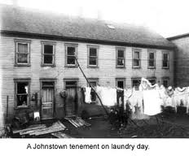

**How is the information above reflected in the story?**

**____________________________________________________________________________________________________________________________________________________________________________________________________________________________________________________________________________________________________________**

**____________________________________________________________**

**Bridging Text and Context**

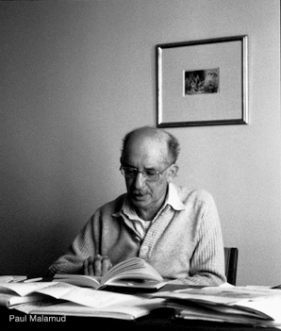Read the background information about the author. How does this information help you understand the story better?

Bernard Malamud (1914-1986) was considered an American writer who wrote about ordinary people, often immigrants. His parents, whom he described as "gentle, honest, kindly people," had come to the United States from Russia in the early 1900s and ran their own grocery store. They were not highly educated and knew very little about literature or the arts. "There were no books that I remember in the house, no records, music, pictures on the wall, “…The family was poor " Malamud said.. Malamud’s mother died when he was 15 years old, and he was unhappy when his father remarried.